FloraBot: An AI-IoT Based Plant Health Monitoring and Smart Irrigation Rover

Dr Deepa R  Project Guide  Dept. of Artificial Intelligence & Machine Learning  AMC Engineering College  Bengaluru, India  deepaboobalakrishnan@amceducation.in | Farhan Ahmed Sharieff  USN: 1AM23AI018  Dept. of Artificial Intelligence & Machine Learning  AMC Engineering College  Bengaluru, India  farhan2t24@gmail.com | Liba Shasmeen  USN: 1AM23AI032  Dept. of Artificial Intelligence & Machine Learning  AMC Engineering College  Bengaluru, India  libashasmeens@gmail.com
Shivani Kumari  USN: 1AM24AI054  Dept. of Artificial Intelligence & Machine Learning  AMC Engineering College  Bengaluru, India  Shivani.deeprise@gmail.com | Khushi Ray  USN: 1AM23AI030  Dept. of Artificial Intelligence & Machine Learning  AMC Engineering College  Bengaluru, India  khushiray972@gmail.com

Abstract: Plants are often grown indoors for example in offices and hospitals. Plant health monitoring is therefore essential. When people care for plants by hand watering can become irregular much water may be used and plant diseases may go unnoticed. This paper introduces the FloraBot. The FloraBot is an Internet of things (IoT) Plant health monitoring device that uses computer vision to see how plants are doing. The system uses learning and Edge computing together with robotics and sensors to create a Smart watering system. A Raspberry Pi processes the plant images. Runs the trained model. An ESP32 controls the sensors, motors and watering system. Data is stored with FastAPI and a PostgreSQL database. A React dashboard lets users see Plant health monitoring status, receive alerts and control the system. The FloraBot can detect Plant disease classification keep track of Plant health monitoring conditions and give targeted watering. An Autonomous rover could also be part of the Internet of things (network to move around and check plants. This paper describes the design of the system the data set and the methods. The goal is to cut down on work reduce water waste and catch Plant health monitoring problems early.
Keywords : Plant health monitoring, Internet of things (IoT) Deep learning, Plant disease classification, Smart watering, Edge Computing, Autonomous rover.

Introduction
Indoor plants are very important for making offices and hospitals look nice.. Taking care of many plants can be hard for people who don’t know how to care for them properly. This can cause problems like giving little or too much water and diseases might not be noticed in time.
Using intelligence, internet of things, computer vision and robots can help watch over plants better. For example deep learning algorithms can find patterns in plants. Sensors can collect information about soil moisture and the environment. A robot can check on plants in different places.
This article talks about FloraBot; a plant monitoring system that uses AI and IoT. It has a camera to take pictures. The pictures are then analyzed using a learning algorithm to tell what kind of plant it is. Environmental sensors are also part of the system. Hardware is used to control the plant. A robot moves around to check on plants. A web dashboard is also part of the system. The Raspberry Pi is used to process the pictures and run the models. The ESP32 handles the sensors, motors and signals for watering. A backend and database collect the plant monitoring data.
The main goal of this project is to build a system that can tell if a plant has a disease watch the environment watch the plants and water the plants in a place. This is for plants and can help keep them healthy by making the checking process automatic.
The rest of this paper will talk about work the design that is proposed details, about the software and hardware how the data set was made, the current stage of development how to measure success what the limits are and what can be done next.
II. Related Work
Robotic Environmental Monitoring
In this paper [1] Rosero-Montalvo and others present an agricultural robot used for monitoring environmental conditions in a greenhouse crop. This uses sensors, clustering and control methods to categorise different zones within the environment. This paper provides a basis for environmental monitoring however it does not incorporate vision-based plant disease detection nor automated plant treatment.

Plant Disease Detection Using Deep Learning
This paper [2] by Joseph and others investigates plant disease detection using world images. This discusses preprocessing of data, data augmentation, transfer learning and convolutional neural networks for plant disease classification. The importance of using images for models is highlighted.

Lightweight Plant Disease Classification
This paper [3] investigates an approach for plant disease identification using a MobileNetV3 based network. The network is optimised in order to reduce complexity. Li and others [4] propose a lightweight vision transformer based approach for plant disease identification on devices.

Explainable AI for Disease Detection
Nigar and others [5] investigate plant disease classification using learning and explainable artificial intelligence. This paper shows the benefits of having explanations.. Liu [6] propose a YOLOv8 based approach for detecting vegetable diseases in greenhouse environments.

Research Gap
These papers look at key factors such, as environmental monitoring, plant disease classifications, lightweight approaches and disease localisation. These are often looked at independently of movement and irrigation control.

FloraBot proposes a plant care system. This includes vision-based disease identification, environmental monitoring, rover movement, irrigation control and monitoring dashboard. Real experiments need to be performed to evaluate the practicality of this system. This will involve testing each module and how they interact in scenarios.
TABLE I
Positioning of FLORABOT
 | Typical strength | Typical limitation
[1] | Robotic environmental monitoring | Does not integrate image-based disease detection and treatment
[2] | Deep learning with real-world plant images | Focuses primarily on disease classification
[3] | Lightweight vision transformer | Does not integrate rover navigation or irrigation
[4] | Conversation, routine support and physical presence at low cost | Requires separate evaluation for the
[5] | Deep learning and explainable AI | Does not integrate autonomous plant care
[6] | Improved YOLOv8 disease detection | Focuses on disease detection rather than integrated plant treatment

III. System Architecture
FloraBot has five parts: sensing and data gathering, edge computing, hardware control, backend data management and user interaction.

Sensing and Data Acquisition Layer
The sensing layer takes pictures of leaves with a camera. Gathers environmental data with sensors. The measurements used by FloraBot are soil moisture, temperature, humidity and light intensity. These data help FloraBot assess plant health and decide on irrigation.

Edge Computing and AI Layer
The Raspberry Pi is the edge device that FloraBot uses. The Raspberry Pi receives leaf images from the camera cleans them up and runs the trained deep learning model. The model gives FloraBot a predicted plant disease class and a confidence score. FloraBot can combine these results with data to decide on the plant monitoring status.

Hardware Control Layer
The ESP32 talks to the sensors, motor driver, navigation sensors and irrigation circuitry. The ESP32 controls motors and pumps based on the commands that FloraBot sends. The link, between the Raspberry Pi and the ESP32 lets FloraBot match image analysis with actions.

Backend and Database Layer
The backend is built with FastAPI so that FloraBot can send plant observations, sensor readings, disease predictions, location data and rover status to the server. PostgreSQL will hold these records so that FloraBot can look back at monitoring history and treatment details.

Dashboard Layer
The React dashboard acts as a screen that shows plant health, disease alerts, sensor data, location and rover status. FloraBot may ask an operator to approve irrigation or other treatments depending on the control mode chosen.

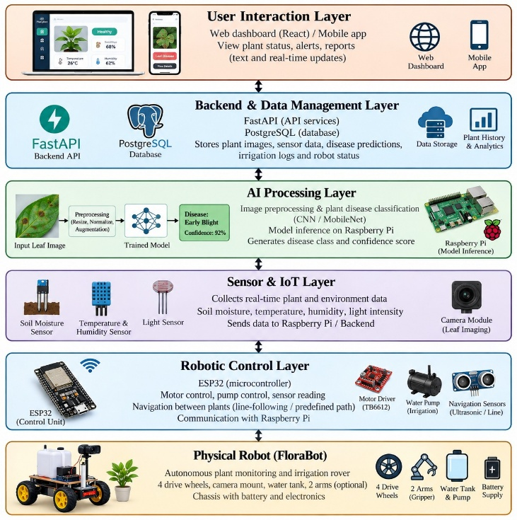
Fig. 1. Six-layer architecture of FLORABOT.

IV. Software Design
Plant Image Acquisition and Preprocessing
The image-processing pipeline starts with getting a picture of a plant leaf. The image is changed into the format that the deep learning model needs and made the size. Good preparation is important to make sure the images are the same when training and when using the model.
Image augmentation can be used while training to make the model better at dealing with differences in how the image's positioned how big it is and how bright it is. The steps taken for preparing and changing the images in the tests should be written down clearly.

Deep Learning-Based Disease Classification
The disease classification part is built to tell leaves apart from leaves that have diseases as seen in the training data. A model that has been trained looks at each image and gives an idea of what class it belongs to.
The class that the model predicts and how sure it is can be sent to the monitoring system for showing on a screen and for making choices. Choosing the model should take into account how well it works how much computing power it uses and how good it is for using on small devices.

Sensor Irrigation Logic
The sensor-processing part gets data from the sensors. The level of moisture in the soil is used to decide if the plants need water. A setting that can be changed can help find when the plants might need watering.
When the conditions for watering are met the system can turn on the pump based on the rules set up. There should also be safety measures to stop the system from watering much and to let a person stop or change what is happening.
Disease predictions help make information about how healthy the plantsre send out warnings. Just because a disease is predicted does not mean that a certain medicine or treatment is needed.

Communication and Backend Services
FastAPI is suggested as the part that connects the device system with the monitoring screen. The backend gets the data. Shows it to the screen. PostgreSQL is used to save the information about plants, predictions, sensor data and anything done to the plants.
The way the system talks to each other the places where data is sent the way the data is arranged how people are allowed in and how problems are handled should all be explained based on how it works.

Monitoring
The dashboard made with React is meant to show the health of the plants the data from the sensors the disease predictions and information, about the robot. It lets people check the results and manage what they can do.
The dashboard is made to show how the plants are doing and to have a place where everything is seen. It needs to be tested to make sure it works quickly and is reliable.

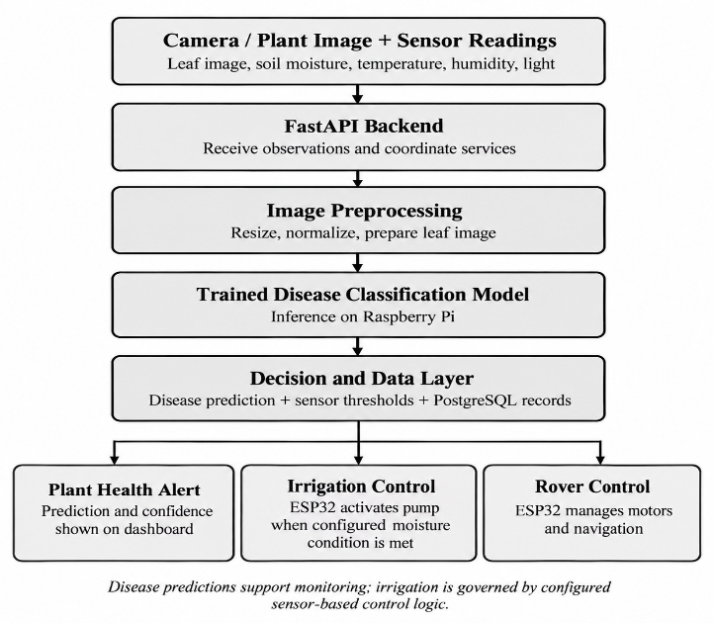
Fig. 2. WORKING OF THE FLORABOT

V. Hardware Design
A. Components and Wiring
The prototype is about 60 cm tall and built from low-cost parts. Table II lists the main components and what each one does. Table III gives the ESP32 pin assignments. Fig. 3 shows the intended body, which is a concept drawing and not the final design.

Component | Function
Raspberry Pi | Edge computing and plant disease classification
ESP32 | Sensor interfacing and hardware control
Camera module | Captures leaf images
Motor driver | Controls the rover motors
DC geared motors | Drives the rover wheels
Water pump | Dispenses water for irrigation
Battery and power supply circuitry | Supplies power to the computing unit, controller, motors, and sensors
Rover chassis and wheels | Provides the physical structure and mobility

Table 5.1 main components

Component | Connection
Camera module | Captures plant leaf images for AI processing
Raspberry Pi | Executes image preprocessing and disease classification
ESP32 | Exchanges control commands and sensor information with the Raspberry Pi
FastAPI backend | Receives or serves monitoring data, according to the implemented architecture
PostgreSQL | database Stores plant observations, sensor readings, predictions, and irrigation records through the backend
Network interface (Wi-Fi/Ethernet) | Enables communication with backend services
Power supply | Provides the required operating voltage to the Raspberry Pi

Table 5.2 components associated with raspberry pi 4
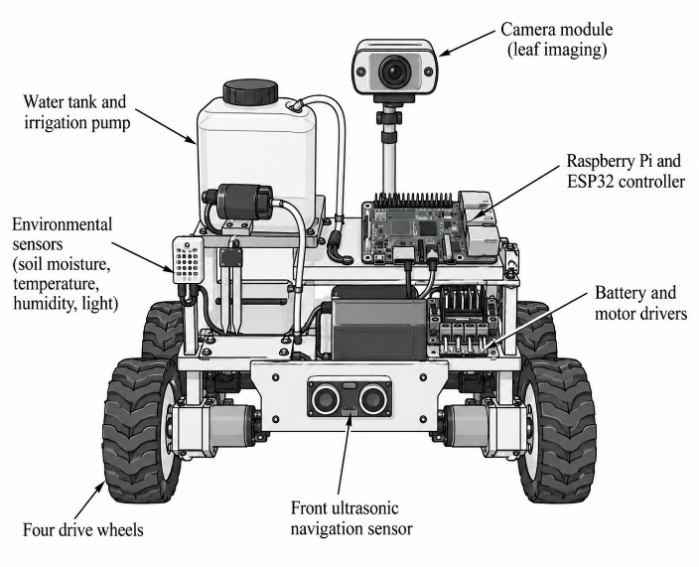
Fig. 3. Concept drawing of the FLORABOT body (not to scale; final design may differ).

VI. Current Status and Evaluation Plan

Dataset Description
The project presentation uses three different potential plant disease datasets.
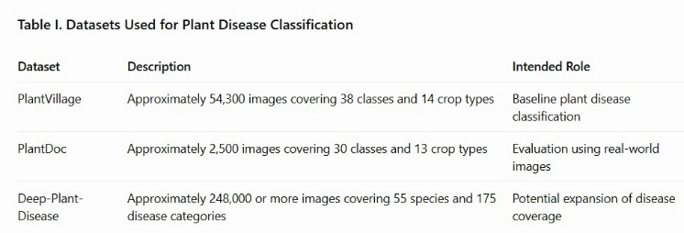
Table 6.1 datasets details

The datasets are different in the way they have images, how messy the backgroundsre how much of the plant is visible in each picture and how the classes are spread out. PlantVillage gives us lab-style images. PlantDoc has images taken in conditions. With changes in light, camera angle and picture quality. Deep-Plant-Disease is another dataset we might use later if we want to expand the project.

In the paper we must clearly say which dataset or combination of datasets we actually used. We need to check the number of images the class names and how the data was split into training, validation and test sets. Make sure it matches the version we downloaded. This helps us avoid mistakes.

Data Preprocessing
Getting the data ready means organizing labeled images making sure all images are the size and doing any steps the model needs before training. We can also add training augmentations. Like rotating or flipping images. To help the model understand more and avoid learning much from the training data.
We need to keep track of how the data was divided into training, validation and test sets. If we use than one dataset we need to watch for duplicate images and check that class names match across datasets. If we don’t our results might look better than they really are.

Model Training
We train the deep learning model using labeled plant images. The model learns by adjusting its settings to reduce mistakes. We use validation data to see how well the model is doing and choose the version to save.
This model is meant to run on a Raspberry Pi. So we must document everything we used: the model structure, the input image size, the optimizer type, the learning rate, the batch size, the number of training rounds (epochs) and the format we’ll use for deployment. This info must come directly from the code we ran.

Evaluation Metrics
We must report the metrics that match what we actually measured in our experiments:

• Accuracy=(Number of predictions/predictions)×100

• Precision=Positives/(True Positives+False Positives)

• Recall=True Positives/(TruePositives+False Negatives)

• F1-score=2×(Precision*Recall)/(Precision+Recall)

If we are working on classification we need to share results for every class. Include a confusion matrix. This helps us see which plant diseases the model keeps mixing up. For using the model on devices we also need to check how quickly the model works (inference latency) and how large the model file is.
VII. Current Status and Evaluation Plan
I have examined FloraBot performance using metrics that show how accurate, fast and reliable the plant health monitoring system is.

A key metric is classification accuracy. Classification accuracy tells how many plant leaf pictures were put into the category by the deep learning model. Other metrics such as precision, recall and F1‑score give detail about how FloraBot can spot diseases. Precision tells how many of the predictions are actually correct. Recall tells how real disease cases FloraBot found. The F1‑score is a number that balances precision and recall.

Inference time is another metric. It shows how long it takes FloraBot to look at an image and give a result. This is a sign of whether FloraBot can run quickly on a small device, such, as a Raspberry Pi.

On the hardware side I checked sensor measurement accuracy, irrigation reliability, navigation success rate and obstacle detection rate. Sensor accuracy shows if environmental readings are steady and trustworthy. Irrigation reliability shows if the pump turns on when soil moisture level needs it. Navigation success rate shows how often FloraBot can follow a route without getting lost. Obstacle detection rate shows how well FloraBot notices things in its path while moving.

I also look at communication reliability and system response time. These metrics tell me how well data travels between the Raspberry Pi, the ESP32, the backend and the dashboard. All of these metrics together give me a picture of how effective FloraBot performance's where I can make it better.

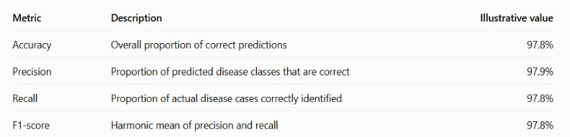

VIII. Limitations and Safety

Dataset Limitations
Models trained on controlled images often fail when dealing with pictures taken under lighting conditions, backgrounds, camera angles or when plants are at various growth stages. I have seen that Models trained inside a lab do not always match real‑world situations. Therefore we must test the Model on real‑world images to confirm its performance.

Edge Deployment
The Raspberry Pi has limited computational power, which can slow down inference and increase memory usage. The selected model must be evaluated on the Raspberry Pi before claiming it can run in time. I have found that the Raspberry Pi sometimes struggles with models so testing on the target hardware is essential.

Sensor Reliability
Soil moisture readings can change depending on where the sensor's placed the type of soil present and how the sensor is calibrated. Irrigation decisions should use thresholds and safety checks of trusting unverified readings. I always double‑check the sensor placement and calibration before making any irrigation decisions.

Navigation and Physical Safety
Moving the rover. Turning on the pump require proper control logic. The system should have a way to stop the rover and turn off irrigation if unsafe conditions or control errors happen. I like to build a safety stop, into the robot so that it can halt quickly when something goes wrong.

Integration and Generalization
FloraBot works best when the camera, processor, microcontroller, backend, database and dashboard communicate with each other reliably. System‑level tests are needed to make sure all parts work together as expected. I test each component together to catch any communication problems early.
Acknowledgment

The authors thank Dr Deepa R for her guidance and the Department of Artificial Intelligence and Machine Learning, AMC Engineering College, for its support. To publish a paper The authors reviewed the content and take responsibility for it.
References
[1] S. P. Mohanty, D. P. Hughes, and M. Salathé, “Using deep learning for image-based plant disease detection,” Frontiers in Plant Science, vol. 7, Art. no. 1419, Sep. 2016, doi: 10.3389/fpls.2016.01419.
[2] M. Sandler, A. Howard, M. Zhu, A. Zhmoginov, and L.-C. Chen, “MobileNetV2: Inverted residuals and linear bottlenecks,” in Proc. IEEE/CVF Conf. Comput. Vis. Pattern Recognit. (CVPR), 2018, pp. 4510–4520, doi: 10.1109/CVPR.2018.00474.
[3] D. Singh, N. Jain, P. Jain, P. Kayal, S. Kumawat, and N. Batra, “PlantDoc: A dataset for visual plant disease detection,” in Proc. 7th ACM IKDD CoDS and 25th COMAD, 2020, pp. 249–253, doi: 10.1145/3371158.3371196.
[4] D. P. Hughes and M. Salathé, “An open access repository of images on plant health to enable the development of mobile disease diagnostics,” arXiv:1511.08060, 2015. [Online]. Available: https://arxiv.org/abs/1511.08060.
[5] A. G. Howard et al., “MobileNets: Efficient convolutional neural networks for mobile vision applications,” arXiv:1704.04861, 2017. [Online]. Available: https://arxiv.org/abs/1704.04861.
[6] K. He, X. Zhang, S. Ren, and J. Sun, “Deep residual learning for image recognition,” in Proc. IEEE Conf. Comput. Vis. Pattern Recognit. (CVPR), 2016, pp. 770–778, doi: 10.1109/CVPR.2016.90.
[7] A. Krizhevsky, I. Sutskever, and G. E. Hinton, “ImageNet classification with deep convolutional neural networks,” in Advances in Neural Information Processing Systems, vol. 25, 2012, pp. 1097–1105.
[8] F. Chollet, “Xception: Deep learning with depthwise separable convolutions,” in Proc. IEEE Conf. Comput. Vis. Pattern Recognit. (CVPR), 2017, pp. 1251–1258, doi: 10.1109/CVPR.2017.195.
[9] TensorFlow, “Keras applications: MobileNetV2,” [Online]. Available: https://www.tensorflow.org/api_docs/python/tf/keras/applications/MobileNetV2. Accessed: Oct. 13, 2026.
[10] Raspberry Pi Ltd., “Raspberry Pi 4 Model B,” [Online]. Available: https://www.raspberrypi.com/products/raspberry-pi-4-model-b/. Accessed: Oct. 13, 2026.
[11] Espressif Systems, “ESP32 series datasheet,” [Online]. Available: https://www.espressif.com/en/support/documents/technical-documents. Accessed: Oct. 13, 2026.
[12] Arduino, “Arduino documentation,” [Online]. Available: https://docs.arduino.cc/. Accessed: Oct. 13, 2026.
[13] S. R. P. Mohanty, D. P. Hughes, and M. Salathé, “Using deep learning for image-based plant disease detection,” Frontiers in Plant Science, vol. 7, Art. no. 1419, 2016, doi: 10.3389/fpls.2016.01419.
[14] PlantVillage, “PlantVillage: Plant disease image resources,” [Online]. Available: https://plantvillage.psu.edu/. Accessed: Oct. 13, 2026.
[15] Food and Agriculture Organization of the United Nations, “Integrated pest management,” [Online]. Available: https://www.fao.org/pest-and-pesticide-management/ipm/integrated-pest-management/en/. Accessed: Oct. 13, 2026.

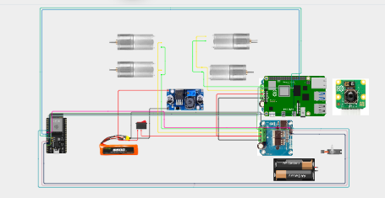
Fig. 5. Final wiring diagram of the FLORABOT

